Python

Install Python on windows

[Download Python | Python.org](https://www.python.org/downloads/)

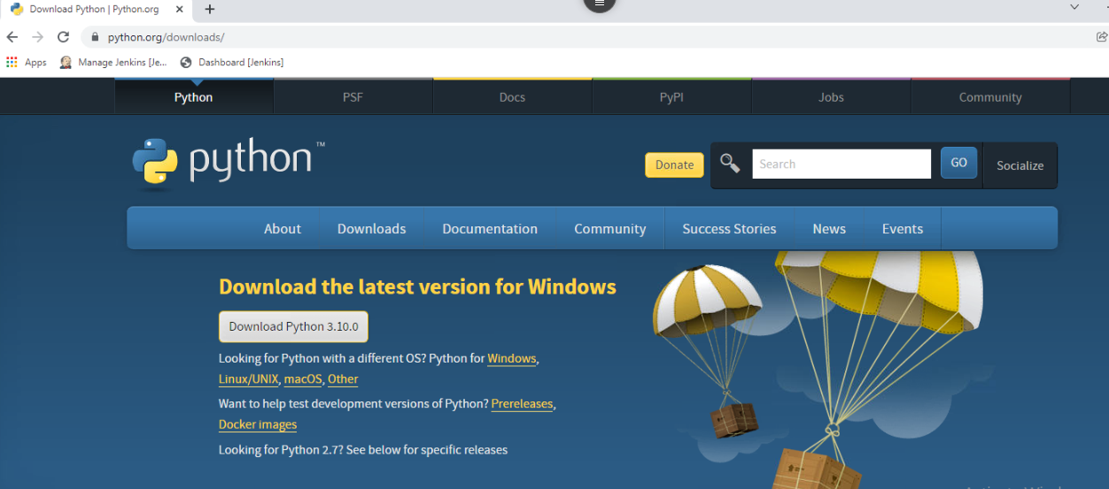

Install Spyder IDE for python:

https://www.filehorse.com/download-spyder-python/download/

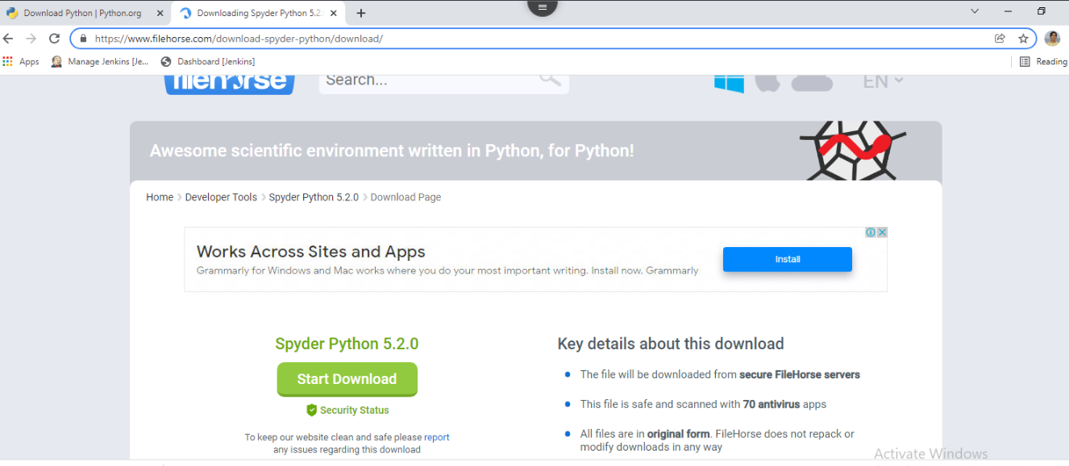

Python is a high-level, interpreted, interactive and object-oriented scripting language. Python is designed to be highly readable.

Python language again has variables, loops, conditional statements, files, exception handling etc.



**Sample programs on Python:**

1.

# Store input numbers

num1 = input('Enter first number: ')

num2 = input('Enter second number: ')

# Add two numbers

sum = float(num1) + float(num2)

# Display the sum

print('The sum of {0} and {1} is {2}'.format(num1, num2, sum))

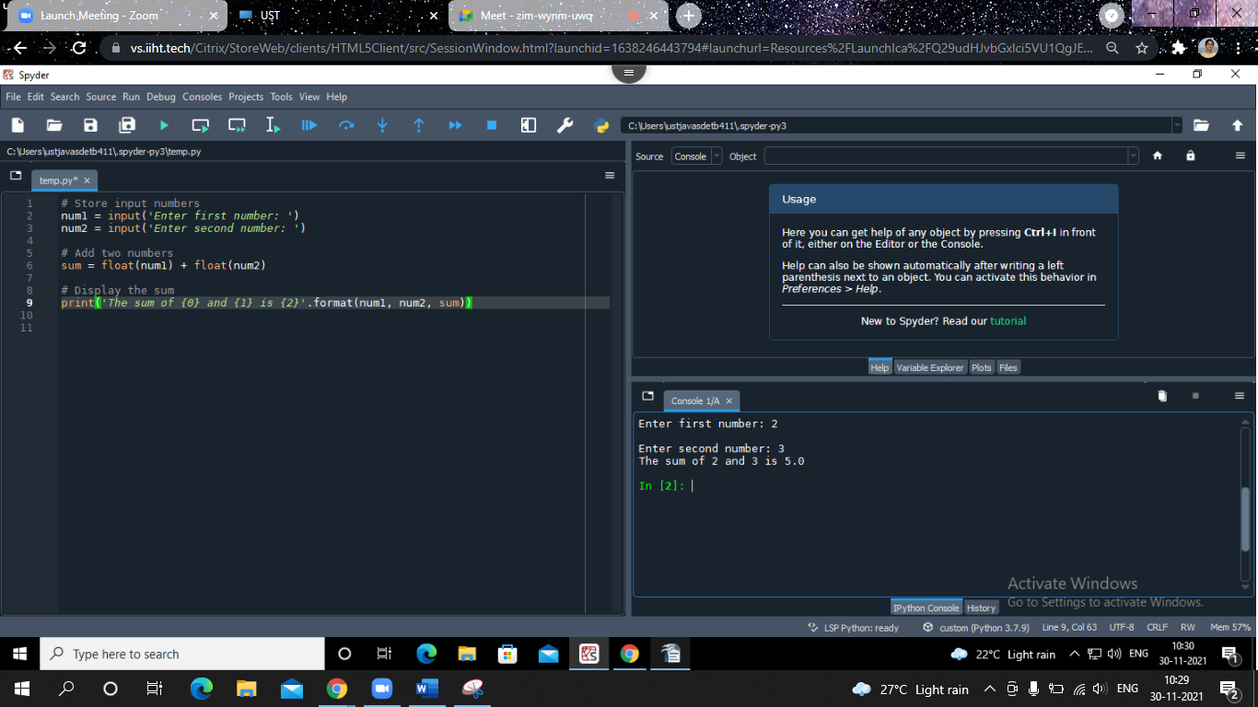

# Python program to swap two variables

x = 5

y = 10

# To take inputs from the user

#x = input('Enter value of x: ')

#y = input('Enter value of y: ')

# create a temporary variable and swap the values

temp = x

x = y

y = temp

print('The value of x after swapping: {}'.format(x))

print('The value of y after swapping: {}'.format(y))

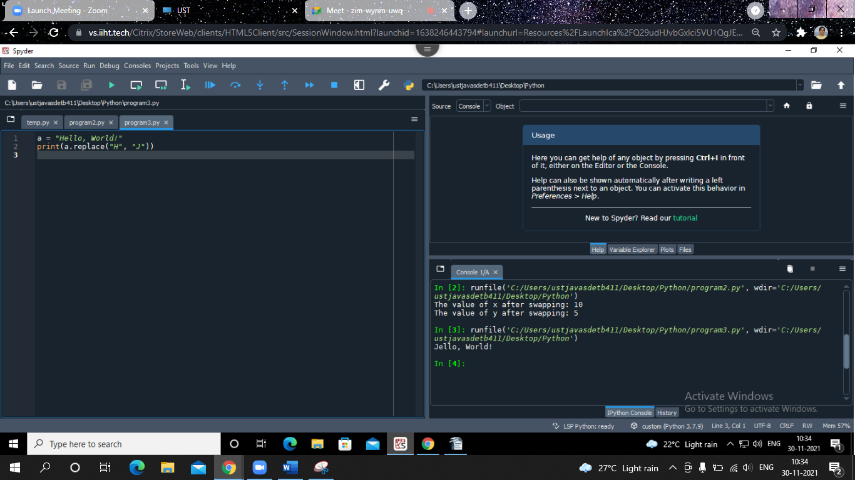

a = "Hello, World!"

print(a.replace("H", "J"))

thislist = ["apple", "banana", "cherry"]

thislist.remove("banana")

print(thislist)

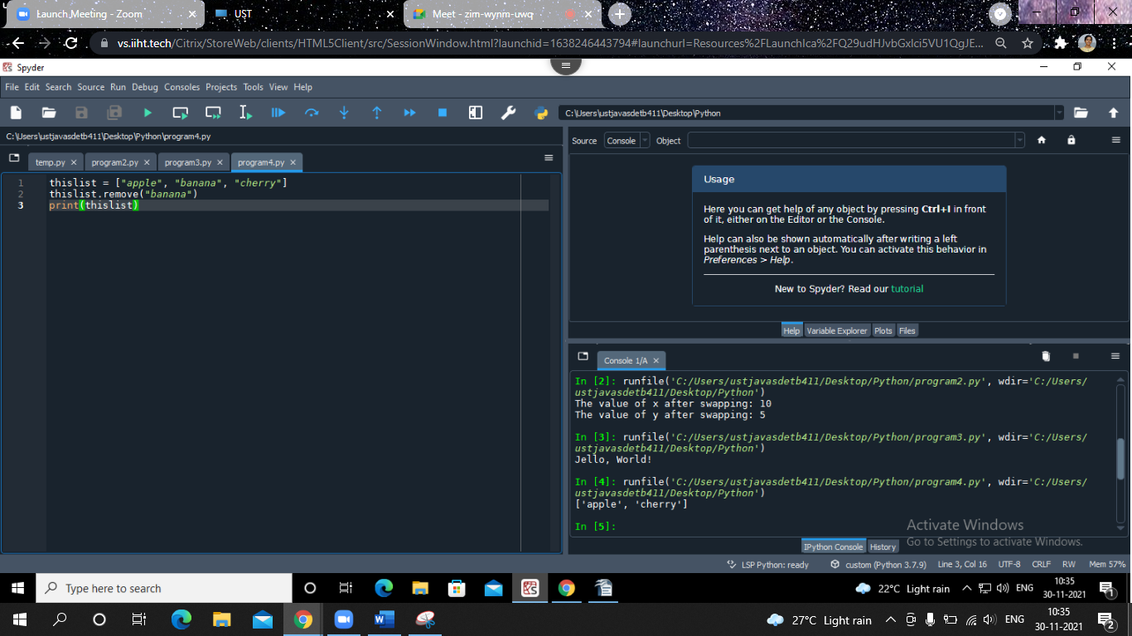

thistuple = ("apple", "banana", "cherry")

print(thistuple)

thistuple = ("apple", "banana", "cherry")

thistuple[1] = "blackcurrant"

# the value is still the same:

print(thistuple)

thisset = {"apple", "banana", "cherry"}

thisset.update(["orange", "mango", "grapes"])

print(thisset)

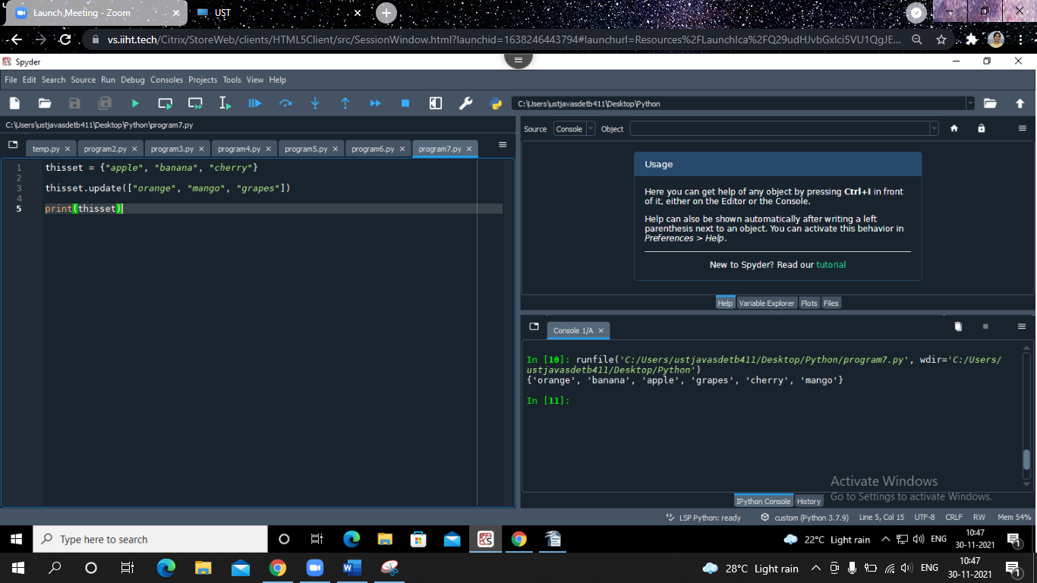

thisdict = {

"brand": "Ford",

"model": "Mustang",

"year": 1964

}

print(thisdict)

thisdict = {

"brand": "Ford",

"model": "Mustang",

"year": 1964

}

for x, y in thisdict.items():

print(x, y)

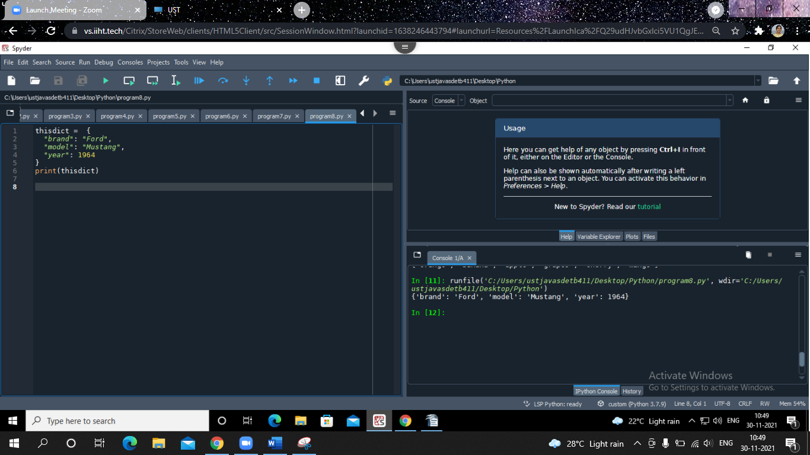

a = 33

b = 33

if b > a:

print("b is greater than a")

elif a == b:

print("a and b are equal")

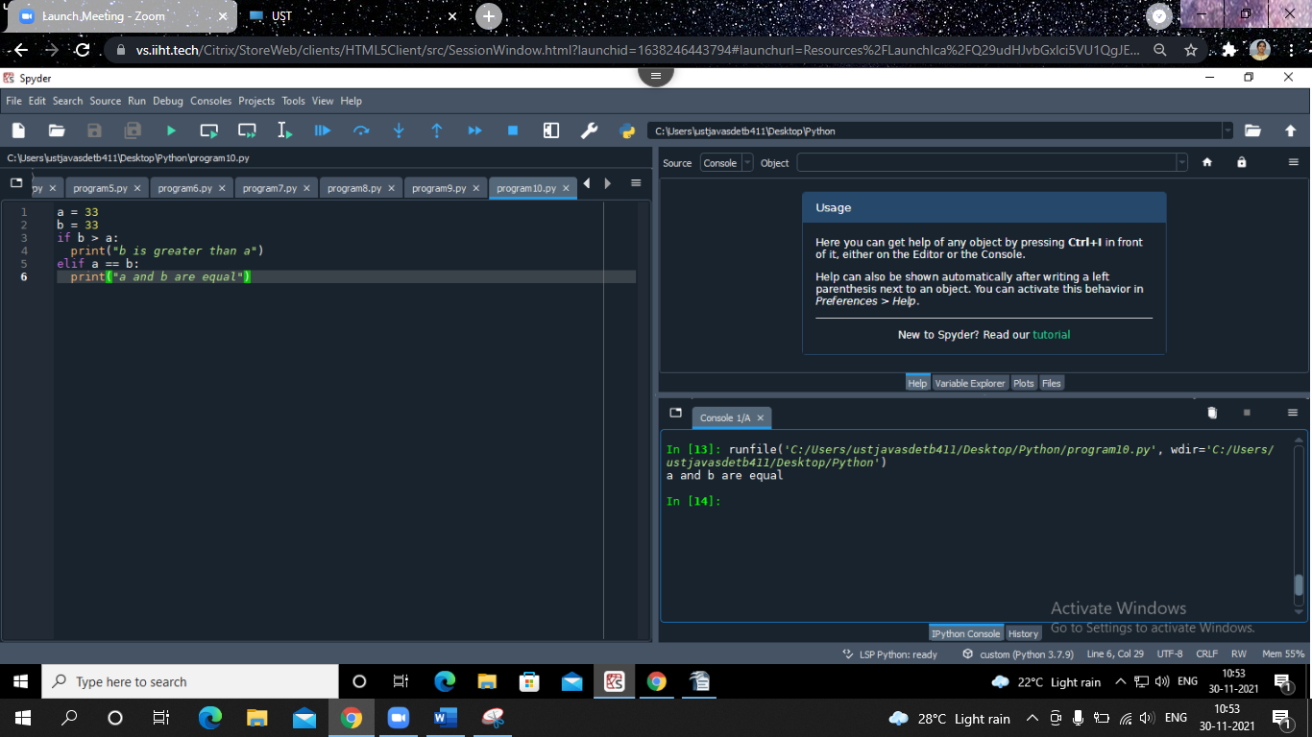

fruits = ["apple", "banana", "cherry"]

for x in fruits:

if x == "banana":

continue

print(x)

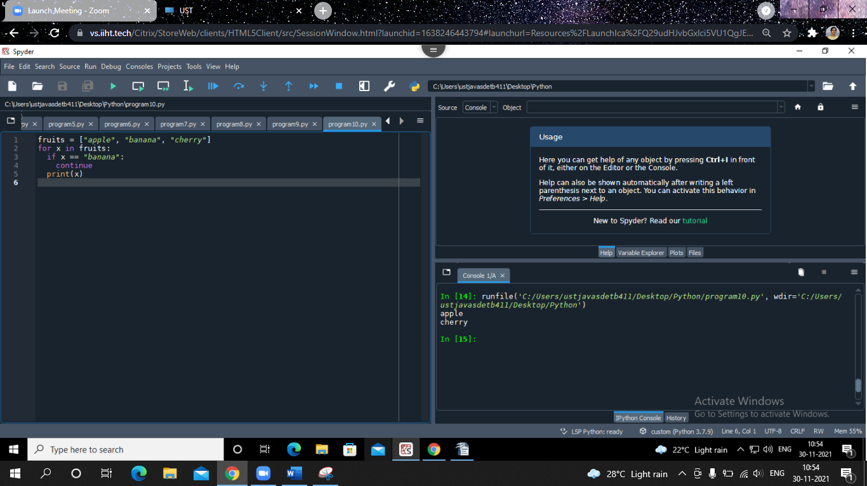

def my_function(country = "Norway"):

print("I am from " + country)

my_function("Sweden")

my_function("India")

my_function()

my_function("Brazil")

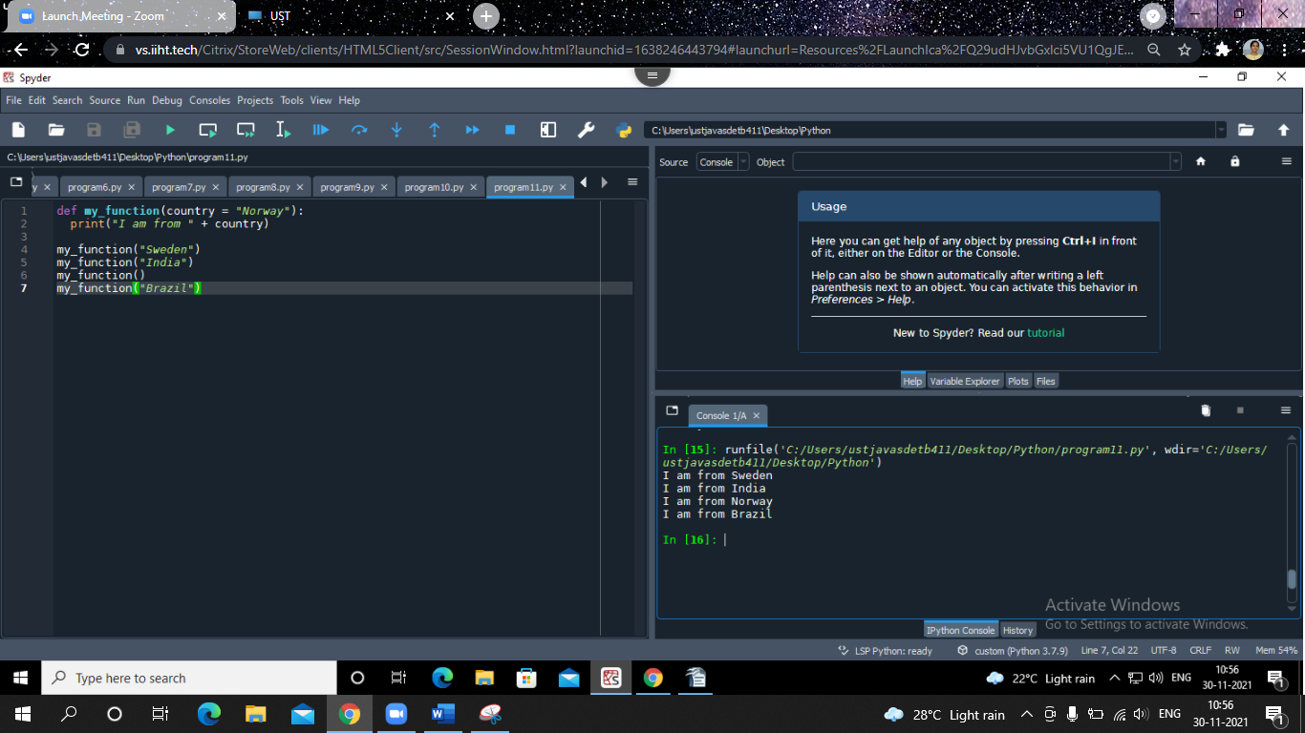

x = lambda a, b, c: a + b + c

print(x(5, 6, 2))

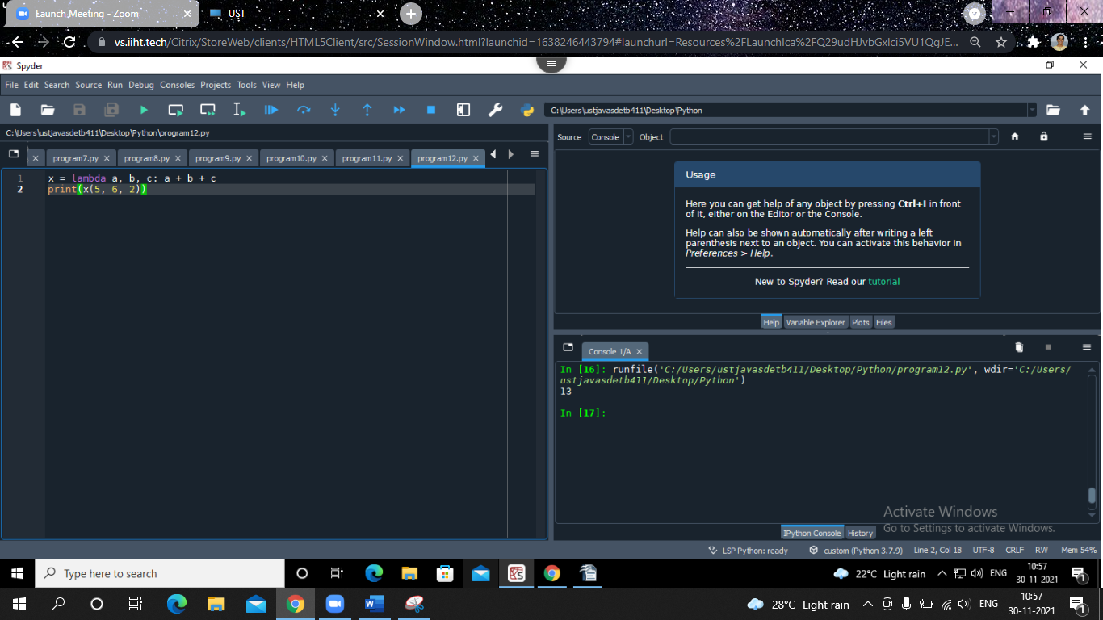

cars = ["Ford", "Volvo", "BMW"]

for x in cars:

print(x)

class Person:

def __init__(self, name, age):

self.name = name

self.age = age

def myfunc(self):

print("Hello my name is " + self.name)

p1 = Person("John", 36)

p1.myfunc()

class MyNumbers:

def __iter__(self):

self.a = 1

return self

def __next__(self):

x = self.a

self.a += 1

return x

myclass = MyNumbers()

myiter = iter(myclass)

print(next(myiter))

print(next(myiter))

print(next(myiter))

print(next(myiter))

print(next(myiter))

import mymodule as mx

a = mx.person1["age"]

print(a)

import json

# some JSON:

x = '{ "name":"John", "age":30, "city":"New York"}'

# parse x:

y = json.loads(x)

# the result is a Python dictionary:

print(y["age"])

import json

x = {

"name": "John",

"age": 30,

"married": True,

"divorced": False,

"children": ("Ann","Billy"),

"pets": None,

"cars": [

{"model": "BMW 230", "mpg": 27.5},

{"model": "Ford Edge", "mpg": 24.1}

]

}

# convert into JSON:

y = json.dumps(x)

# the result is a JSON string:

print(y)

import re

#Split the string at every white-space character:

txt = "The rain in Spain"

x = re.split("\s", txt)

print(x)

f = open("demofile.txt", "r")

for x in f:

print(x)

Python Frameworks: (HAVE AN IDEA):

[A Beginner’s Introduction to Python Frameworks | by STX Next | Medium](https://medium.com/@STXNext/a-beginners-introduction-to-python-frameworks-d1d47b8e99a3)

[An Introduction to Python Frameworks - DZone Web Dev](https://dzone.com/articles/an-introduction-to-python-frameworks)

